420-D10

Lab 08

Airline System

**Airline System Data Model**

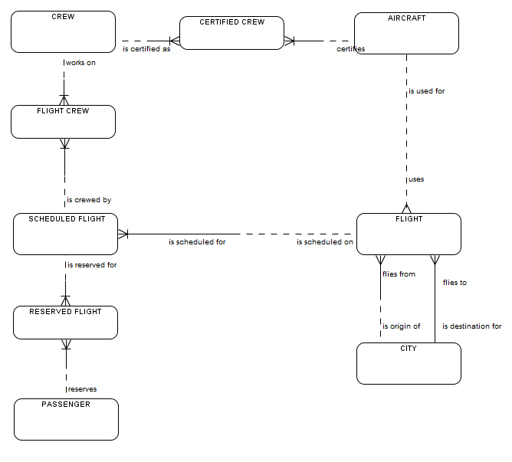

**Airline Business Rules**

1. A flight flies between two cities leaving and arriving at the same time each day.
2. A passenger makes a reservation for a specified flight on a specified day.
3. Each scheduled flight has a crew of at least three people: the pilot, co-pilot and at least one flight attendant. There may also be a first officer and more flight attendants.
4. There are two categories of employee – pilot and flight attendant.
5. A flight flies between two cities.
6. The departure and arrival cities are identified by airline codes. (e.g. YOW is Ottawa).
7. Only a pilot can be certified on an aircraft.
8. A crew member cannot be both a flight attendant and a pilot.
9. A pilot may work as pilot, co-pilot or first officer on a flight.

**Sample Airline Forms**

|  |  |  |  |  |  |
| --- | --- | --- | --- | --- | --- |
| **Flight #** | **Aircraft** | **From** | **To** | **Depart** | **Arrive** |
| HR129 | CRA | YOW | YQM | 9:05 | 11:50 |
| HR128 | 777 | YOW | YFC | 9:05 | 10:55 |
| HR101 | DH1 | YOW | YHZ | 12:15 | 12:48 |
| HR533 | 321 | YUL | YFC | 13:45 | 17:05 |
| HR534 | DH1 | YHZ | YUL | 16:45 | 18:10 |
| HR535 | 777 | YSJ | YOW | 18:45 | 20:05 |
| HR536 | DH1 | YFC | YUL | 12:20 | 12:25 |
| HR537 | DH1 | YUL | YOW | 13:25 | 14:02 |

Flight schedule

Flight Confirmation Form

### **Passenger Reservation Confirmation**

Reservation Number: ABC123

Passenger Name: Sam Ovar

Phone Number: 819 555-5555

Date of Issue: 18/09/10

|  |  |  |  |  |  |  |  |
| --- | --- | --- | --- | --- | --- | --- | --- |
| **ITINERARY** | | | | | | | |
| **Flight**  **Number** | **Aircraft** | **Depart** | | | **Arrive** | | |
| **City** | **Date** | **Time** | **City** | **Date** | **Time** |
| HR128 | 777 | Ottawa (YOW) | 19-10-14 | 9:05 | Fredericton (YFC) | 19-10-14 | 10:55 |
| HR536 | DH1 | Fredericton (YFC) | 29-10-14 | 12:20 | Montreal (YUL) | 29-10-14 | 12:25 |
| HR537 | DH1 | Montreal (YUL) | 29-10-14 | 13:25 | Ottawa (YOW) | 29-10-14 | 14:02 |

Crew Roster for Flight HR128 on 19-10-10

|  |  |  |  |  |
| --- | --- | --- | --- | --- |
| **Crew id** | **Name** | **Position** | **Flight** | **Flight Role** |
| 1234 | Snoopy Dog | Pilot | HR128 | Pilot |
| 1233 | Red Baron | Pilot | HR128 | Co-pilot |
| 1232 | Charles Brown | Flight Attendant | HR128 | Flight Attendant |
| 1222 | Lucy Smith | Flight Attendant | HR128 | Flight Attendant |
| 1241 | Peppermint Patty | Flight Attendant | HR128 | Flight Attendant |

Pilot Certifications

| **Crew-id** | **Aircraft Code** | **Aircraft Manufacturer and Model** | **Last Date of Certification** |
| --- | --- | --- | --- |
| 1234 | 777 | Boeing 777-300ER | 20-03-14 |
| 1233 | 777 | Boeing 777-300ER | 18-10-13 |
| 1234 | DH1 | de Havilland Dash 8-100 | 15-11-13 |
| 1233 | DH1 | de Havilland Dash 8-100 | 28-06-14 |
| 1233 | CRA | Canadair CRJ-705 | 26-04-13 |
| 1234 | 321 | Airbus A321-200 | 02-06-14 |

Library System

